# T-SQL Project by Roger Hartley

My Goals for this T-SQL Project are:-

* Build on the SQL knowledge I learned during the Google Data Analytics Associate Certification that I completed.
* Have fun as I learn more T-SQL skills and get used to the software tools I might need.
* Show prospective employers that I am willing to learn T-SQL as much as possible and that I do have some skills in using it.

Goal 1: – Get to know the dataset

* I decided to use the easily available AdventureWorksLT2022 database which can be found at <https://learn.microsoft.com/en-us/sql/samples/adventureworks-install-configure?view=sql-server-ver17&tabs=ssms>
* I installed Server 2022 Developer Edition with SSMS 21 on my local PC and I restored the sample dataset in use.
* I looked at some of the tables to get a feel for the data. For example:-

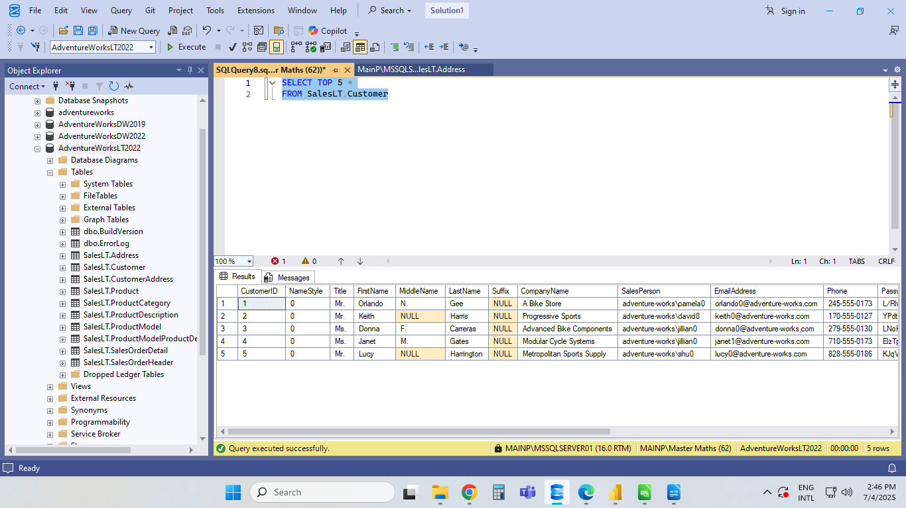

* I also wanted to look for possible columns that could be used as primary keys and foreign keys. For example Customer ID here.
* I noticed many of the fields had NULL values. I was going to have to decide how I was going to handle these.
* I needed to look out for any obvious mistakes in the data entered and do some data cleaning if necessary.
* I need to keep the long term goal in mind and consider what story the data may tell should I have to present my findings to stakeholders, or if I need to build an insightful BI report that I could share.

Goal 2: Execute Some Queries

* I wanted to try a basic filter query first. I decided to filter out products that started with Road in their names and order them by highest list price. I would look at a top 10 list and include any ties.

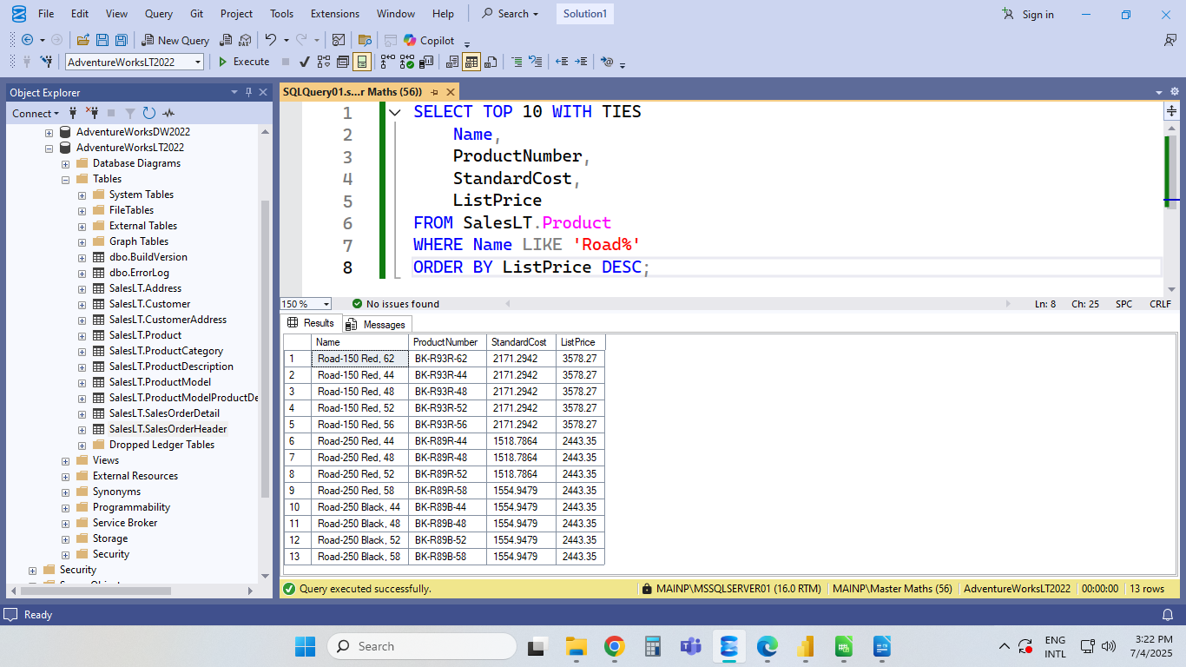

* The result returned 13 rows and not 10 as there was a tie from 6th to 13th.
* I was curious as to how many different products Adventure Works had, and so I executed and received the following printout.

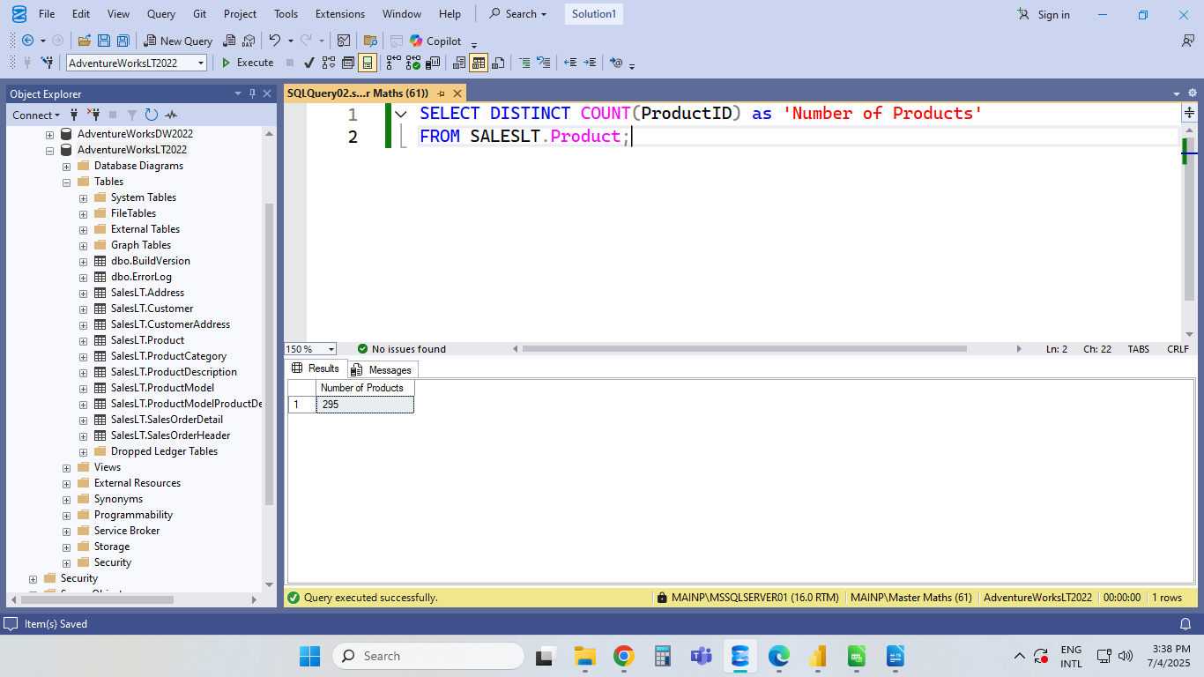

* There are 295 different products sold at Adventure Works.
* I figured that the stakeholders would want to know who the biggest customers are, and so I created a Query and received the following output.
* 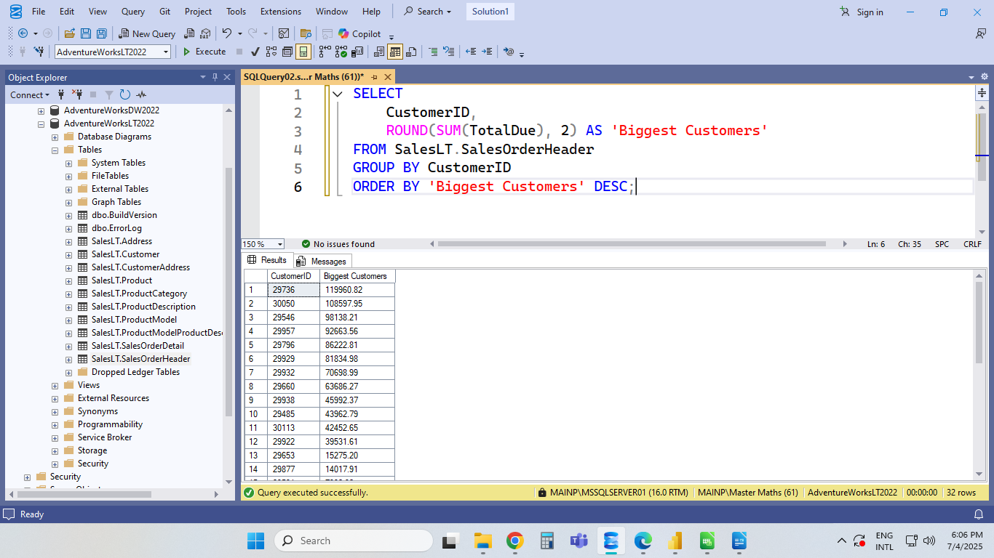As can be seen, I have them sorted by customer ID. What if the stakeholders wanted names instead?
* I created a query and was able to give them far more information. It required a left join and I blanked out the NULL values. This is how it looks now.
* 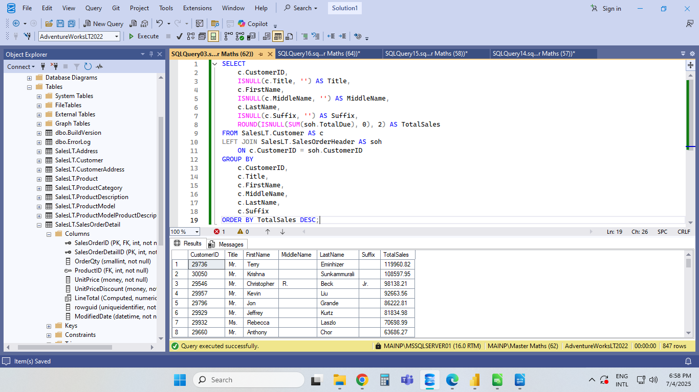This document showcased my approximate T-SQL skills as at 2025-07-07. I required the help of ChatGPT to rectify some of my queries that initially did not work and where my syntax needed some tweaking.